Transversal Line
# Source: AI Source: Provided by: [Data Path: Persons Table -> ID Column: 1, Name_En Column: Motasem Essam] -> From: [ChatGPT] on [7/25/2026]
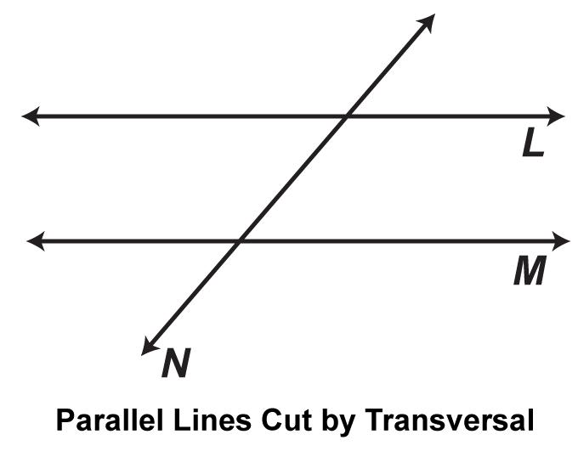
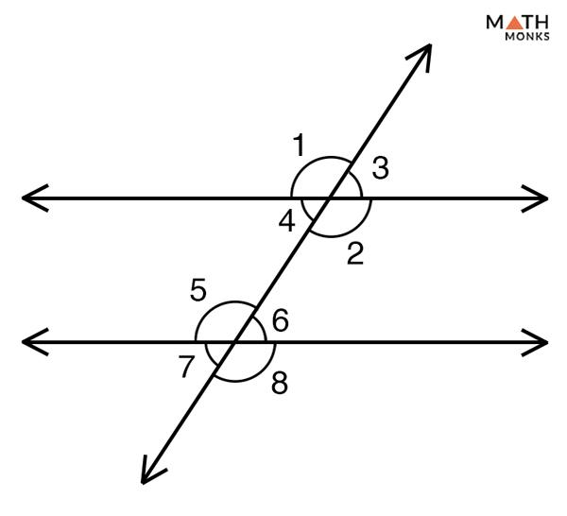
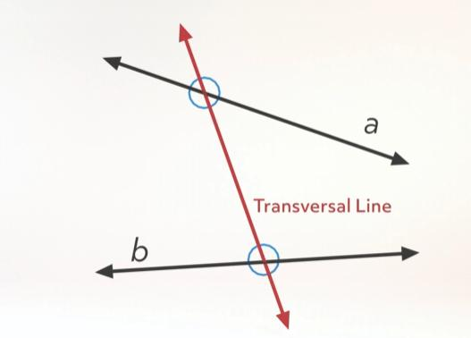
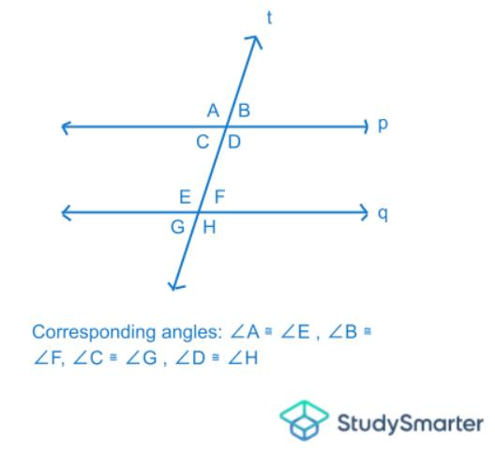
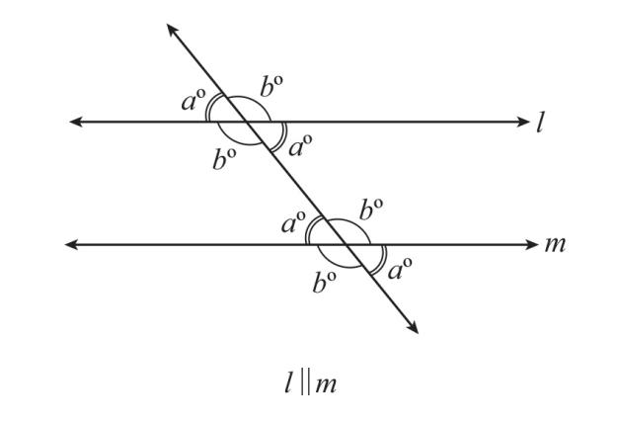

Definition
# Source: AI Source: Provided by: [Data Path: Persons Table -> ID Column: 1, Name_En Column: Motasem Essam] -> From: [ChatGPT] on [7/25/2026]
A Transversal Line is a line that intersects two or more other lines at different points. The intersected lines are often parallel, but they do not have to be.
A transversal creates several pairs of angles whose relationships are important in plane geometry.

Characteristics
# Source: AI Source: Provided by: [Data Path: Persons Table -> ID Column: 1, Name_En Column: Motasem Essam] -> From: [ChatGPT] on [7/25/2026]
A transversal line:
- Intersects two or more lines.
- Meets each line at a different point.
- Can intersect parallel or non-parallel lines.
- Forms multiple pairs of related angles.
- Is fundamental in studying angle relationships.

Illustration
# Source: AI Source: Provided by: [Data Path: Persons Table -> ID Column: 1, Name_En Column: Motasem Essam] -> From: [ChatGPT] on [7/25/2026]
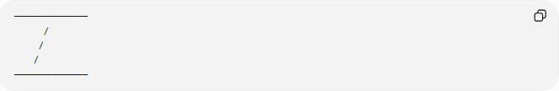
───────────────
/
/
/
───────────────
The slanted line is the transversal because it intersects both horizontal lines.

Mathematical Representation
# Source: AI Source: Provided by: [Data Path: Persons Table -> ID Column: 1, Name_En Column: Motasem Essam] -> From: [ChatGPT] on [7/25/2026]
If a line $t$intersects lines $l_{1}$and $l_{2}$, then:
$$t∩l_{1}=P \\ t∩l_{2}=Q$$
where:
- $P$and $Q$are different intersection points.

Common Illustration
# Source: AI Source: Provided by: [Data Path: Persons Table -> ID Column: 1, Name_En Column: Motasem Essam] -> From: [ChatGPT] on [7/25/2026]
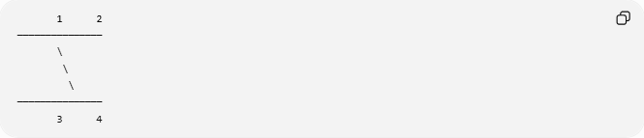
1 2
───────────────
\
\
\
───────────────
3 4
The diagonal line is the transversal.

Angle Relationships
# Source: AI Source: Provided by: [Data Path: Persons Table -> ID Column: 1, Name_En Column: Motasem Essam] -> From: [ChatGPT] on [7/25/2026]
When a transversal line intersects two parallel lines, it forms eight angles. These angles have several important relationships that are fundamental in plane geometry.

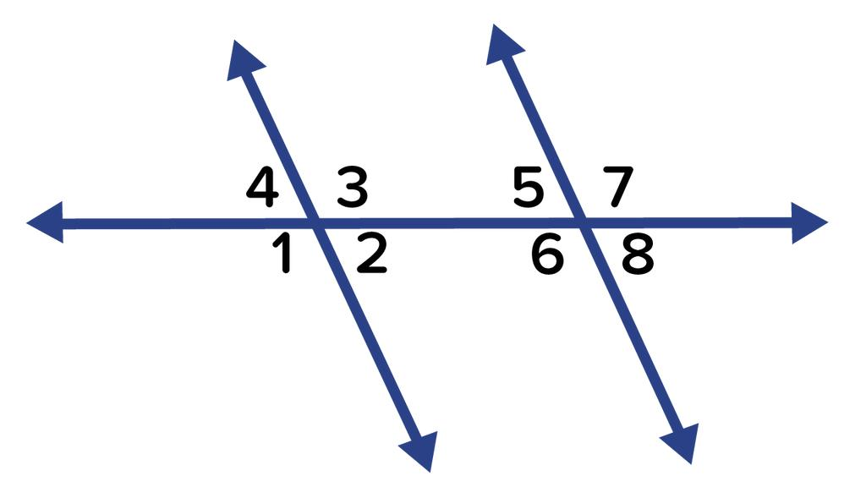
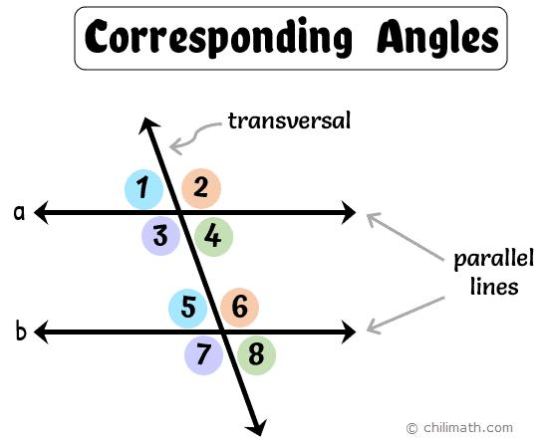

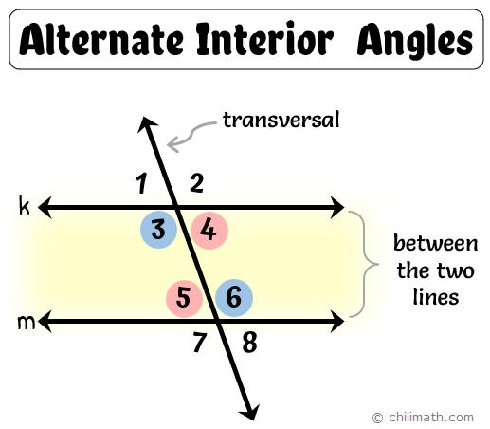
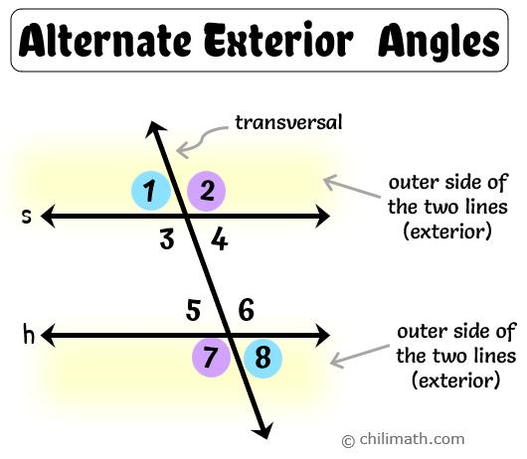

Standard Numbering
# Source: AI Source: Provided by: [Data Path: Persons Table -> ID Column: 1, Name_En Column: Motasem Essam] -> From: [ChatGPT] on [7/25/2026]
The following numbering is commonly used.
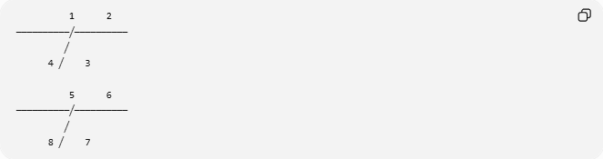
1 2
──────────╱──────────
╱
4 ╱ 3

5 6
──────────╱──────────
╱
8 ╱ 7

1. Corresponding Angles
# Source: AI Source: Provided by: [Data Path: Persons Table -> ID Column: 1, Name_En Column: Motasem Essam] -> From: [ChatGPT] on [7/25/2026]
Definition
Corresponding angles occupy the same relative position at each intersection formed by the transversal.
They are equal only when the two lines are parallel.

Angle Pairs
$$∠1=∠5 \\ ∠2=∠6 \\ ∠3=∠7 \\ ∠4=∠8$$

Property
If
$$l_{1}∥l_{2}$$
then
$$\text{Corresponding angles are equal.}$$

Example
If
$$∠2={65}^{∘}$$
then
$$∠6={65}^{∘}$$

2. Alternate Interior Angles
# Source: AI Source: Provided by: [Data Path: Persons Table -> ID Column: 1, Name_En Column: Motasem Essam] -> From: [ChatGPT] on [7/25/2026]
Definition
These angles lie:
- Between the two parallel lines
- On opposite sides of the transversal

Angle Pairs
$$∠3=∠5 \\ ∠4=∠6$$

Property
If the lines are parallel,
$$\text{Alternate interior angles are equal.}$$

Example
If
$$∠4={72}^{∘}$$
then
$$∠6={72}^{∘}$$

3. Alternate Exterior Angles
# Source: AI Source: Provided by: [Data Path: Persons Table -> ID Column: 1, Name_En Column: Motasem Essam] -> From: [ChatGPT] on [7/25/2026]
Definition
These angles lie:
- Outside the two parallel lines
- On opposite sides of the transversal

Angle Pairs
$$∠1=∠7 \\ ∠2=∠8$$

Property
If the lines are parallel,
$$\text{Alternate exterior angles are equal.}$$

Example
If
$$∠1={48}^{∘}$$
then
$$∠7={48}^{∘}$$

4. Same-Side Interior Angles
# Source: AI Source: Provided by: [Data Path: Persons Table -> ID Column: 1, Name_En Column: Motasem Essam] -> From: [ChatGPT] on [7/25/2026]
(Also called Consecutive Interior Angles or Co-Interior Angles)
Definition
These angles lie:
- Between the parallel lines
- On the same side of the transversal

Angle Pairs
$$∠3+∠6={180}^{∘} \\ ∠4+∠5={180}^{∘}$$

Property
Same-side interior angles are supplementary.

Example
If
$$∠3={110}^{∘}$$
then
$$∠6={70}^{∘}$$
because
$${110}^{∘}+{70}^{∘}={180}^{∘}$$

5. Vertical (Vertically Opposite) Angles
# Source: AI Source: Provided by: [Data Path: Persons Table -> ID Column: 1, Name_En Column: Motasem Essam] -> From: [ChatGPT] on [7/25/2026]
Definition
Vertical angles are opposite each other at the same intersection.
They are always equal.

Upper Intersection
$$∠1=∠3 \\ ∠2=∠4$$

Lower Intersection
$$∠5=∠7 \\ ∠6=∠8$$

Property
Vertical angles are equal whether or not the lines are parallel.

6. Adjacent Angles
# Source: AI Source: Provided by: [Data Path: Persons Table -> ID Column: 1, Name_En Column: Motasem Essam] -> From: [ChatGPT] on [7/25/2026]
Definition
Adjacent angles:
- Share one common side
- Share one common vertex

Examples
$$∠1+∠2={180}^{∘} \\ ∠2+∠3={180}^{∘} \\ ∠3+∠4={180}^{∘}$$

Property
Adjacent angles that form a straight line are supplementary.

Summary Table
# Source: AI Source: Provided by: [Data Path: Persons Table -> ID Column: 1, Name_En Column: Motasem Essam] -> From: [ChatGPT] on [7/25/2026]
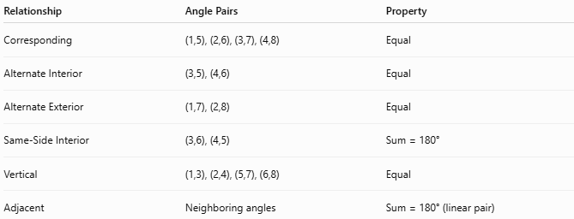
Relationship | Angle Pairs | Property
Corresponding | (1,5), (2,6), (3,7), (4,8) | Equal
Alternate Interior | (3,5), (4,6) | Equal
Alternate Exterior | (1,7), (2,8) | Equal
Same-Side Interior | (3,6), (4,5) | Sum = 180°
Vertical | (1,3), (2,4), (5,7), (6,8) | Equal
Adjacent | Neighboring angles | Sum = 180° (linear pair)

Examples
# Source: AI Source: Provided by: [Data Path: Persons Table -> ID Column: 1, Name_En Column: Motasem Essam] -> From: [ChatGPT] on [7/25/2026]
Examples of transversal lines include:
- A road crossing multiple parallel streets.
- A railway crossing parallel tracks.
- A ladder leaning across parallel rails.
- A diagonal beam crossing horizontal supports.

Properties
# Source: AI Source: Provided by: [Data Path: Persons Table -> ID Column: 1, Name_En Column: Motasem Essam] -> From: [ChatGPT] on [7/25/2026]
A transversal:
- Intersects at least two lines.
- Produces multiple angles at each intersection.
- Creates predictable angle relationships when intersecting parallel lines.
- Can intersect lines at any angle.

Applications
Transversal lines are used in:
- Plane Geometry
- Coordinate Geometry
- Engineering
- Architecture
- Construction
- Surveying
- CAD (Computer-Aided Design)
- Technical Drawing
- Computer Graphics
- Transportation Design

Advantages
# Source: AI Source: Provided by: [Data Path: Persons Table -> ID Column: 1, Name_En Column: Motasem Essam] -> From: [ChatGPT] on [7/25/2026]
Studying transversal lines helps to:
- Solve angle problems.
- Prove lines are parallel.
- Construct geometric figures.
- Analyze structural layouts.
- Understand geometric relationships.

Limitations
# Source: AI Source: Provided by: [Data Path: Persons Table -> ID Column: 1, Name_En Column: Motasem Essam] -> From: [ChatGPT] on [7/25/2026]
A transversal:
- Does not imply the intersected lines are parallel.
- Special angle relationships apply only when the intersected lines are parallel.

Comparison with Other Types of Lines
# Source: AI Source: Provided by: [Data Path: Persons Table -> ID Column: 1, Name_En Column: Motasem Essam] -> From: [ChatGPT] on [7/25/2026]
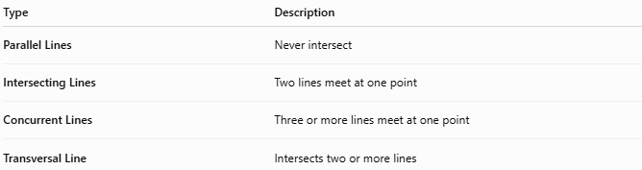
Type | Description
Parallel Lines | Never intersect
Intersecting Lines | Two lines meet at one point
Concurrent Lines | Three or more lines meet at one point
Transversal Line | Intersects two or more lines

Key Points
# Source: AI Source: Provided by: [Data Path: Persons Table -> ID Column: 1, Name_En Column: Motasem Essam] -> From: [ChatGPT] on [7/25/2026]
- A Transversal Line intersects two or more lines.
- It creates several angle pairs.
- When crossing parallel lines, it produces predictable angle relationships.
- Transversal lines are widely used in geometry, engineering, architecture, surveying, CAD, and technical drawing.

Conclusion
# Source: AI Source: Provided by: [Data Path: Persons Table -> ID Column: 1, Name_En Column: Motasem Essam] -> From: [ChatGPT] on [7/25/2026]
A Transversal Line is a line that intersects two or more other lines at different points, making it one of the most important concepts in plane geometry. When it intersects parallel lines, it creates well-defined angle relationships—including corresponding, alternate interior, alternate exterior, and same-side interior angles—that are fundamental to geometric proofs and problem solving. Transversal lines are extensively used in plane geometry, coordinate geometry, engineering, architecture, construction, surveying, CAD, transportation design, and computer graphics, where analyzing intersections and angular relationships is essential for accurate design and spatial reasoning.

